Parkinson’s
Parkinson’s in gait: https://physionet.org/content/gaitpdb/1.0.0/
https://github.com/BioDigitalRnd/machine-learning/blob/master/code/TestAix/PD/Analysing_pd_in_gait.py
- contains 93 patients with Pd and 73 healthy patients
- Sensors attached to each patients’ feet’s they were tested to walk at a comfortable pace for 2 minutes (speed_01 in columns)
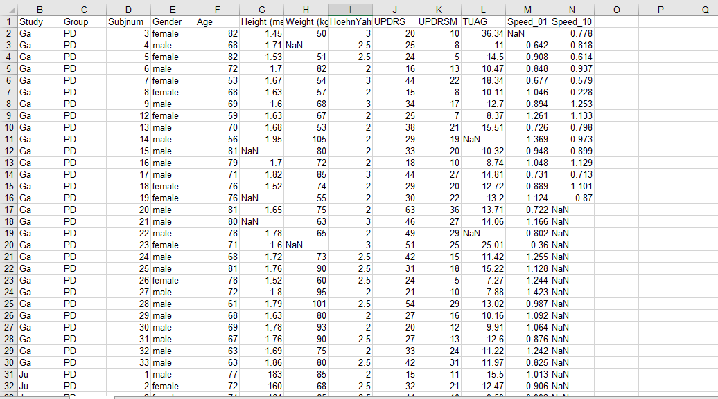
- Using the ‘Group’ column as the label I compared it with the (Height, Weight, Updrs/Updrsm, HoehnYahr, Tuag and Speed_01) and fed 25% of the data to train the random forest model. I had done this to make it so the model will predict whether a patient would have parkinson’s or not depending on what values you give it.

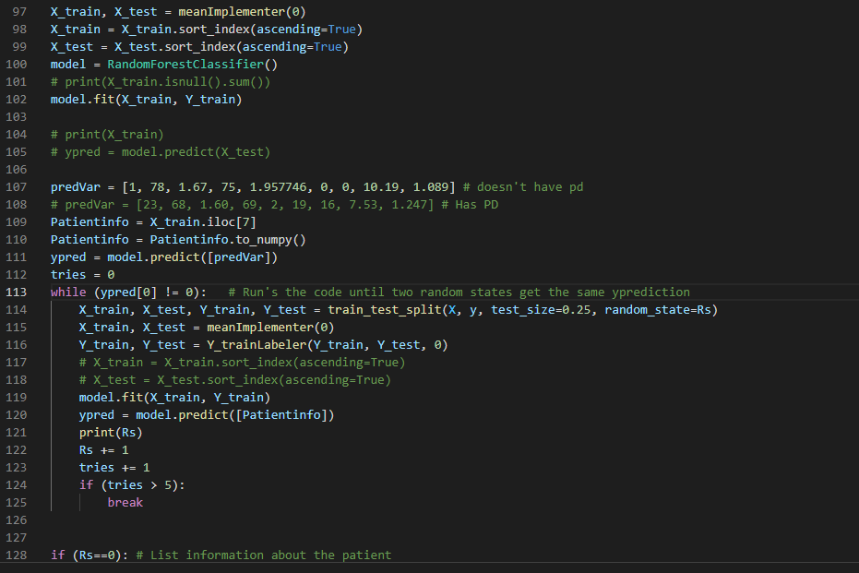

* ypred = values of the patient you’re predicting has pd or not
- A correlation was found that patients with a higher severity of parkinson’s on average had a slower constant speed (speed_01) compared to those with a lower severity.
Column labels:
Speed_01 - constant speed
Unified Parkinson's Disease Rating Scale (UPDRS)
https://www.ncbi.nlm.nih.gov/pmc/articles/PMC4545638/#:~:text=The%20Unified%20Parkinson's%20Disease%20Rating%20Scale%20(UPDRS)%20is%20the%20most,)%20Motor%20Examination%20%5B2%5D
Timed Up and Go test (TUAG): which is a reliable measure of functional performance that captures transfers, gait, and turning movements
https://www.sciencedirect.com/topics/medicine-and-dentistry/timed-up-and-go-test#:~:text=One%20example%20is%20the%20Timed,%2C%20gait%2C%20and%20turning%20movements
Hoehn and Yahr Scale: is a commonly used system for describing how the symptoms of Parkinson's disease progress
https://www.physio-pedia.com/Hoehn_and_Yahr_Scale

Parkinson’s in Voice: https://www.kaggle.com/dipayanbiswas/parkinsons-disease-speech-signal-features
https://github.com/BioDigitalRnd/machine-learning/blob/master/code/TestAix/PD/Analysing_pd_voice.py
* according to this article: https://braininformatics.springeropen.com/articles/10.1186/s40708-020-00113-1
Tremor and voice recording are key indicators to predicting if a patient would get parkinson’s.
- Traditional diagnosis of Parkinson’s involves taking a neurological history of the patient and observing motor skills in various situations. This case study was developed to see if machine learning algorithms could be applied to a voice recording dataset to accurately diagnose PD, making it an effective screening step prior to an appointment with a clinician.
- The patients average, maximum and minimum vocal fundamental frequencies are marked down which will allow us to get a good indicator on the range a patient with Parkinson’s vocal frequency lies under compared to a patient without. This could be used to train our models to try to predict if x Patient of a certain vocal frequency will get Parkinson’s or not according to this data.

Column Headers:
- Matrix column entries (attributes):
- name - ASCII subject name and recording number
- MDVP:Fo(Hz) - Average vocal fundamental frequency
- MDVP:Fhi(Hz) - Maximum vocal fundamental frequency
- MDVP:Flo(Hz) - Minimum vocal fundamental frequency
- MDVP:Jitter(%),MDVP:Jitter(Abs),MDVP:RAP,MDVP:PPQ,Jitter:DDP - Several
- measures of variation in fundamental frequency
- MDVP:Shimmer,MDVP:Shimmer(dB),Shimmer:APQ3,Shimmer:APQ5,MDVP:APQ,Shimmer:DDA - Several measures of variation in amplitude
- NHR,HNR - Two measures of ratio of noise to tonal components in the voice
- status - Health status of the subject (one) - Parkinson's, (zero) - healthy
- RPDE,D2 - Two nonlinear dynamical complexity measures
- DFA - Signal fractal scaling exponent
- spread1, spread2,PPE - Three nonlinear measures of fundamental frequency variation

Other Parkinson dataset:
* Effect of Intranasal Insulin on Parkinson’s: https://physionet.org/content/inipdmsa/1.0/
^ 16 subjects:
of the 16, 8 in the INI group (taking insulin) and 6 in placebo completed the verbal fluency (FAS) test
For FAS, participants were asked to name words starting with letters F, A and S over a one-minute interval.
^ PD-Table1 – contains the data summary table which includes their pre- and post-intervention study variables and their values on each subject:
- Group (Insulin-Placebo)
- Demographics
- Disease (PD, MSA)
- Laboratory
- Vital Signs
- Walking Test
- Montreal Cognitive Assessment (MoCA)
- Becker Depression Inventory (BDI)
- Verbal Fluency (FAS)
Pd-Table2 – contains the data which includes the pre- and post-intervention UPDRS values for every subject. The columns updrsN_base and updrsN_tre1 refer to pre- and post-treatment respectively.
Abbreviations:
- MoCA = the Montreal Cognitive Assessment
- HY = Hoehn and Yahr Scale
- BDI = Beck Depression Inventory
- F,A,S = phonemic fluency and verbal memory
- UPDRS= Unified Parkinson Disease Scale I-III
- SBP= systolic blood pressure
- DBP= diastolic blood pressure.

* How Parkinson affect typing speed: https://physionet.org/content/nqmitcsxpd/1.0.0/ - article backing up research: https://journals.plos.org/plosone/article?id=10.1371/journal.pone.0188226
^ PD_MIT_CS2PD - 31 subjects, 13 healthy controls and 18 PD sufferers
Pd_MIT_CS2PD – 54 subjects, 30 healthy controls and 24 PD sufferers
Column Header:
- pID - Patient ID
- gt - Ground truth label of whether or not they had PD
- updrs108 - Unified Parkinson’s Disease Rating Scale part III (UPDRS-III)
- afTap - Alternating finger tapping result
- sTap - Single key tapping result
- nqScore - neuroQWERTY index (nQi)
- Typing speed
- file_n - The csv file(s) containing the patient's typing data

